

**Basic Linux Commands Assignments**

Assignment-1

Connect and disconnect with login Access

* What happens when you login a non-existent users or username?
  + Provide Screenshot and What you understand, explain in short brief?

**Ans:**

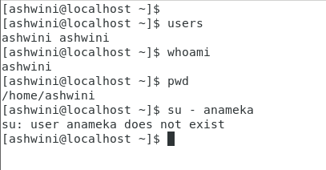

**Explanation:**

When we login as a non-existent user for example user name : anameka

It throughs an error saying “user anameka does not exist”, it means that the user anameka does not exist in the Linux home directory or login directory.

Assignment-2

Password changing

* Login into your account and then change password?
  + Change your password into **IneuR0n#42** and hit the **Enter** key
    - Explain what happen and give screenshot?
  + Try again to change password but use like password ***1234*** or ***abcd***
    - Explain what happen and give screenshot?
  + Try again to change password but now don’t use any password just hit **Enter** key
    - Explain what happen and give screenshot?

**Ans:**

**Change password:**  passwd

Change current password to new password

Password got changed

**Change password** to 1234, unable to change password to 1234

It’s throughing an error saying “bad password, password strength not met”

Change password and don’t use password, error saying “authentication token manipulation error”, it did not work.

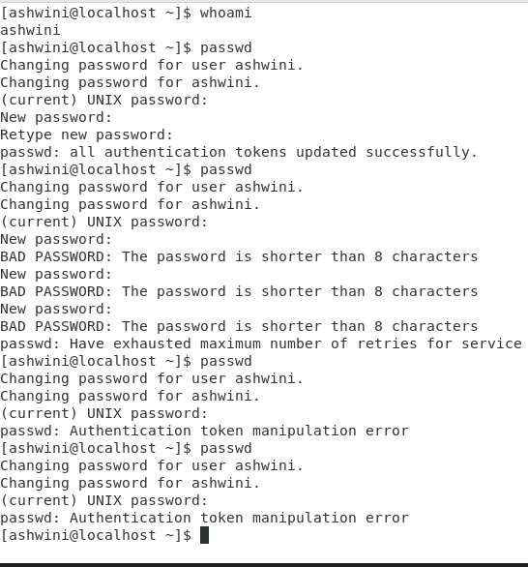

Assignment-3

Working with Directories

* Enter the command **cd /** and then **ls** and then hit **Enter** key
  + Take screenshot and explain what output we got?

**Ans:**

Enter cd : Change directory command

Cd /: takes to the root directory of current directory.

Listing different file systems in Linux.

/bin, /var, /etc, /dev files .

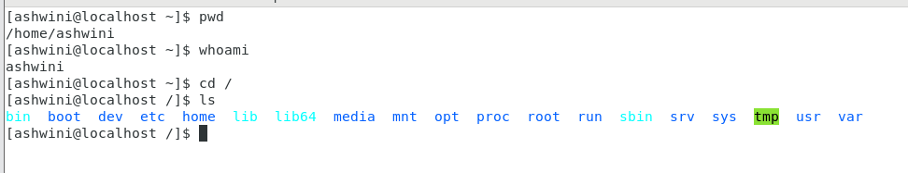

* Enter the command now **cd /home** and then hit **Enter** key
  + Do **ls,** provide screenshot and explain what is **/home** directory used for?

Ans:

Cd /home: goto home directory

Every user in linux has its own home directory with this home directory user can store all their login scripts, files, user information.

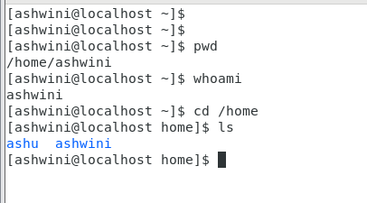

* Enter **cd ..** and hit **Enter** key [ *Note: here we have space after cd then use double dot*]
  + Check what happen and give screenshot?

**Ans:**

Enter Cd .. : Change to parent of current directory

It goes back to its parent directory.

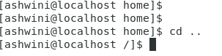

* Now enter **cd /var/www/html** and then type **cd** and hit **Enter** key
  + Explain what happen and give screenshot?

**Ans:**

In /var file we don’t have /www and /html files, hence it did’t work.

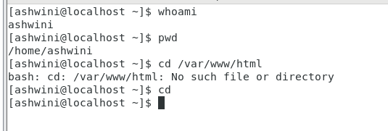

Listing /var :



* Now type **cd /root** and then hit **Enter** key
  + Do **ls,** check any output we have on screen if yes then take screenshot?

**Ans:**

Unable to do **cd /root** from user Ashwini : cd /root as permission denied

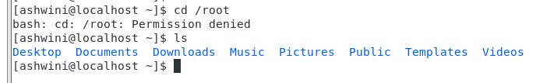

Logged in as sudo and did listing : ls

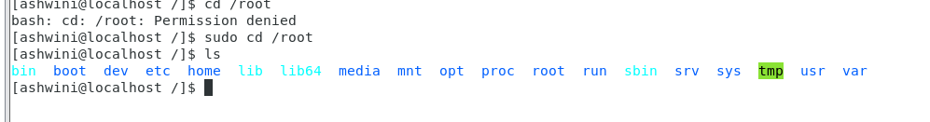

**Assignment-4**

Working with File Listing

* Go to **cd /etc** and type **ls**
  + Take screenshot and explain what files you have seeing?
  + Take screenshot and explain what different output you found compare to previous command you used?

**Ans:**

Enter cd /etc: listing all configuration files.

/etc directory contains all configuration files.

“/etc" is used for configurations (.conf files etc). and all the configs and settings for the system.

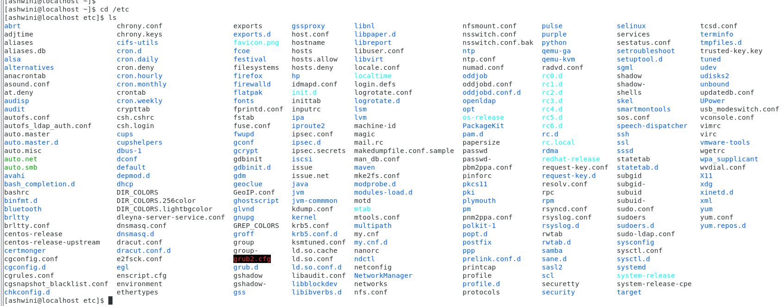

The /var directory is the location for "variable" things like logs, running process ID pointer files, spool directories, and other things important for running services.

* Then type **ls -al** and hit **Enter** key
  + Take screenshot and explain what new file or directory you found?

**Ans:** Enter cd /etc: listing all configuration files.

/etc directory contains all configuration files.

Command “ls” : listing all files and directories.

Options in ls command

“l” – long listing format of files and directories

“a” – list all hidden files and directories

“i” – print index number of each files and directories

“g”- list all files and directories with the group name

“r”- list all files and directories in reverse order

“R”- short list all directories

“t”- sorted by modified time, started with newest files

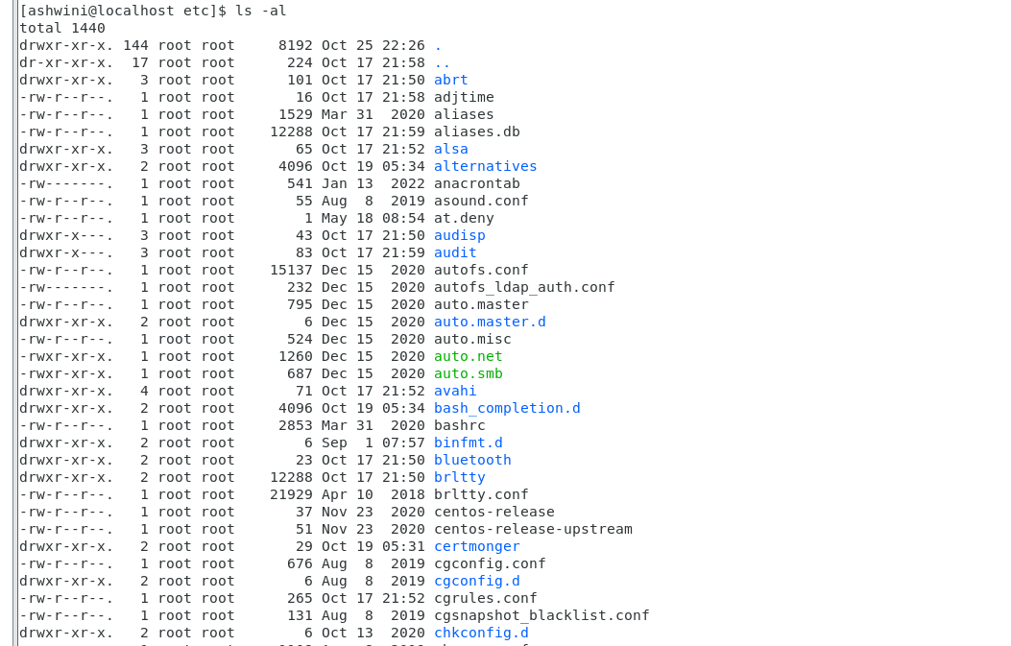

* Then use **ls -i** and hit **Enter** key
  + Now see what different output its shows and take screenshot?

**Ans:**

Command “ls” : listing all files and directories.

Options in ls command

“l” – long listing format of files and directories

“a” – list all hidden files and directories

“i” – print index number of each files and directories

“g”- list all files and directories with the group name

“r”- list all files and directories in reverse order

“R”- short list all directories

“t”- sorted by modified time, started with newest files

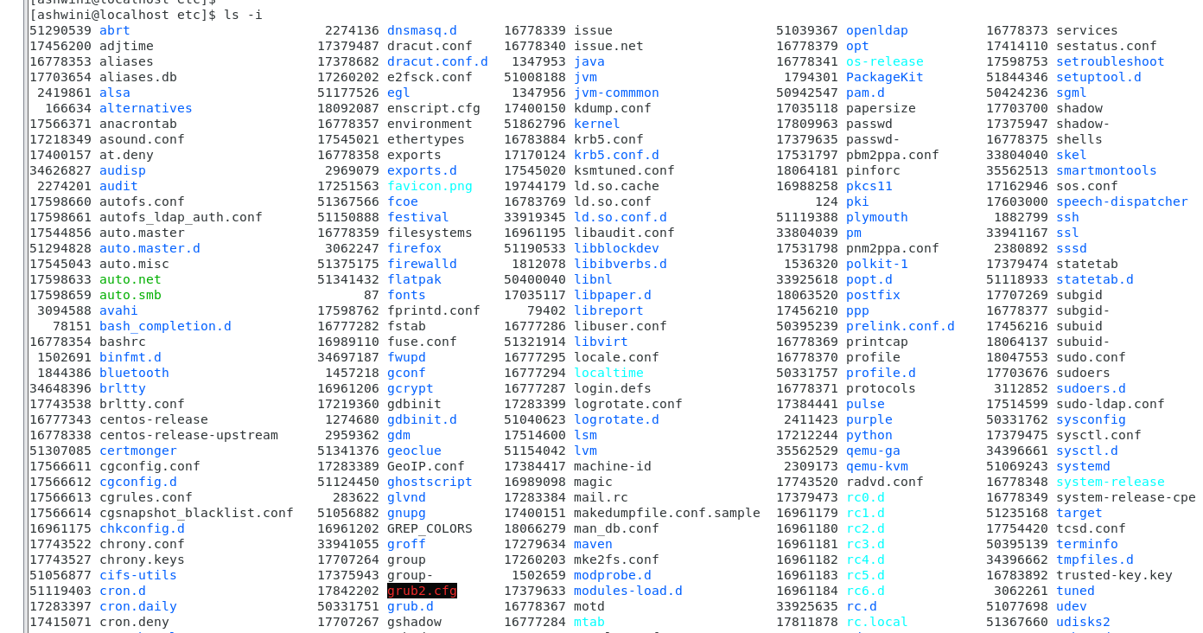

* Then use **ls –help** and see other options about **ls** command
  + Explore it and try with other attribute we can use with **ls** command

**Ans:**

Command “ls” : listing all files and directories.

Options in ls command

“l” – long listing format of files and directories

“a” – list all hidden files and directories

“i” – print index number of each files and directories

“g”- list all files and directories with the group name

“r”- list all files and directories in reverse order

“R”- short list all directories

“t”- sorted by modified time, started with newest files

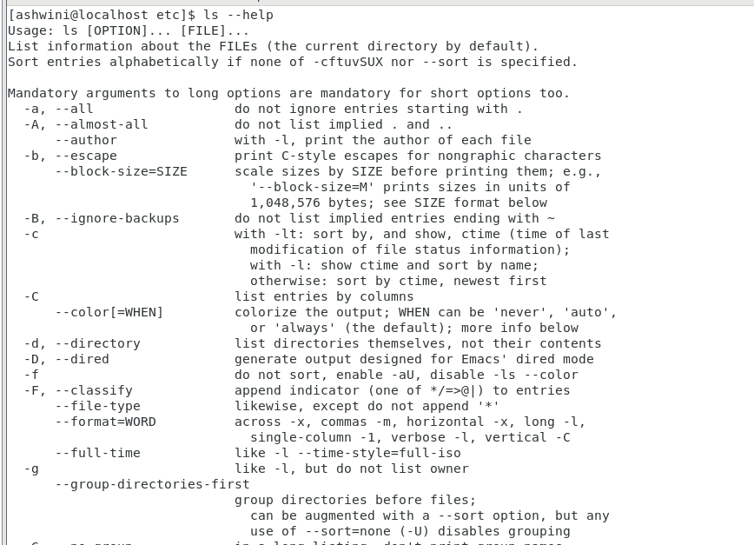

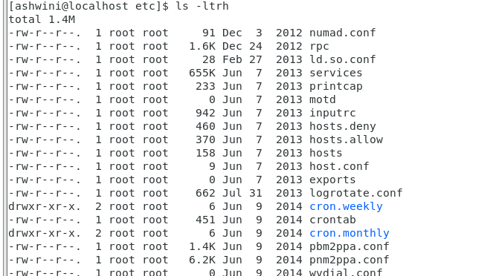

Assignment-5

Know where you are and where you working

*Here we use* ***pwd, cd and ls*** *as combine task to understand where you working on terminal and how you can switch from one directory to another one.*

* Open terminal after restart the linux
  + Check which location you working, type **pwd** and take screenshot
* Now use **cd /var** and hit **Enter** key
  + Do **ls,** and see what output comes, give screenshot?
* Do explore other help options of each command to learn more other things we can do with these commands

**Ans:**

